- There are four elements to an explicit cursor
    - Declaring the cursor
      - Select statement does NOT contain an INTO clause
      - Any valid select statement may be used, this includes joins, sub queries and unions
      - FOR UPDATE is an optional clause that locks all records retrieved by the select statement
      - Variables must be declared before the cursor is opened
    - Opening the cursor
      - The result set is determined
      - A pointer is set “before the first row” in the result set
    - Fetching results into PL/SQL variables
      - Pointer is moved to next row and the next record is fetched
      - The variables must be data type compatible with the select list in the cursor
    - Closing the cursor
      - After the result set has been processed the cursor should be closed so the resources can be freed
      - After the cursor is closed it is illegal to fetch from it
      - Note: if the cursor is re-opened, the original first record will still be the first record

- Cursor Attributes - attribute name is appended to the cursor name
    - %FOUND
      - Boolean attribute indicating if the previous fetch returned a row
      - TRUE = returned a record; FALSE = nothing returned
      - Will raise an exception if referenced both before the cursor is opened and after the cursor is closed
      - Value is null after the cursor is opened and before the first fetch
    - %NOTFOUND
      - Boolean attribute indicating if the previous fetch did not return a row
      - TRUE = nothing returned; FALSE = returned a record
      - Will raise an exception if referenced both before the cursor is opened and after the cursor is closed
      - Value is null after a cursor is opened and before the first fetch
    - %ROWCOUNT
      - Number of rows that have been fetched (so far)
      - Will raise an exception if referenced both before the cursor is opened and after the cursor is closed
      - Value is zero after the cursor is opened and before the first fetch
    - %ISOPEN
      - Boolean attribute indicating the current open status of the cursor
      - TRUE = cursor is open; FALSE = cursor is not open

- Example of passing parameters to a cursor
    - Declaring the cursor
CURSOR c_employee (cv_start_date DATE, cv_dept NUMBER) is
SELECT First_Name, Last_Name
FROM Employee
WHERE Date_Hired > cv_start_date and
Department = cv_dept;
*Note: the data types can NOT have any delimiters
    - Opening the cursor
OPEN c_employee (’01-Jan-2005’, 12345);
    - The balance of the steps (Fetch, Loop and Close) remain the same

- Syntax
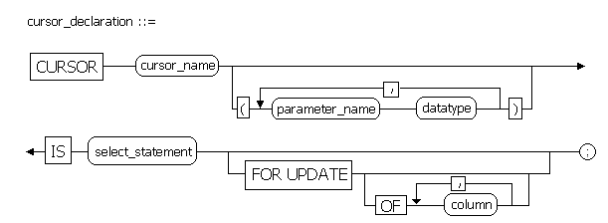
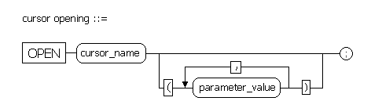
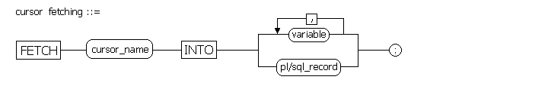
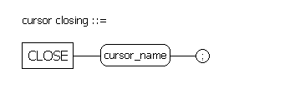
ADDENDUM - “while loop” and “exit when loop” coding comparison

1. Create a test table:
CREATE TABLE loop_test (
Sid number (6, 0),
SName varchar2 (50),
EDate date,
Loop_Type varchar2 (50));
2. Create a procedure to populate the test table using both types of loops:

CREATE OR REPLACE PROCEDURE PR_LOOPS
IS
v_sid number (6, 0);
v_sname varchar2 (50);
v_edate date;

CURSOR cursor_name IS SELECT Sid, SName, EDate
FROM MM_Student;
BEGIN
-- open the cursor and insert the records with the while loop
OPEN cursor_name;
FETCH cursor_name INTO v_sid, v_sname, v_edate;
WHILE cursor_name%FOUND
LOOP
INSERT INTO loop_test
(Sid, SName, EDate, Loop_Type)
VALUES
(v_sid, v_sname, v_edate, 'inserted by WHILE LOOP');
FETCH cursor_name INTO v_sid, v_sname, v_edate;
END LOOP;
CLOSE cursor_name;
-- re-open the cursor and insert the same records with the exit when loop
OPEN cursor_name;
LOOP
FETCH cursor_name INTO v_sid, v_sname, v_edate;
EXIT WHEN cursor_name%NOTFOUND;
INSERT INTO loop_test
(Sid, SName, EDate, Loop_Type)
VALUES
(v_sid, v_sname, v_edate, 'inserted by EXIT WHEN LOOP');
END LOOP;
CLOSE cursor_name;

END PR_LOOPS;
/
3. Execute the procedure, then do a select statement to retrieve all the rows from the test table:

